# INTRODUCTION:-

# Overview

# Human resource management is the strategic approach to nurturing and supporting employees and ensuring a positive workplace environment. Its functions vary across different businesses and industries, but typically include recruitment, compensation and benefits, training and development, and employee relations.

# https://borgenproject.org/wp-content/uploads/HR-Human-Resources-Management.jpg

# What is the main purpose of HR?



In simplest terms, the HR (Human Resources) department is a group who is responsible for managing the employee life cycle (i.e., recruiting, hiring, on boarding, training, and firing employees) and administering employee benefits.

2. Design Thinking:-

2.1 Empathy map

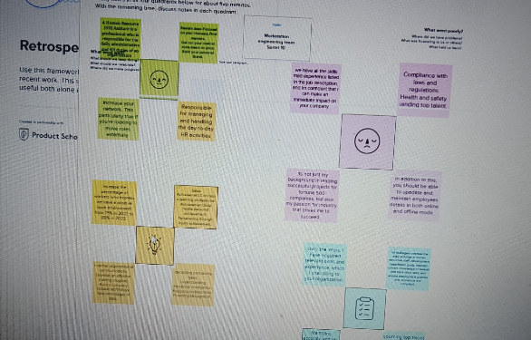

# 2.2 Ideation and brainstorming map screenshot:

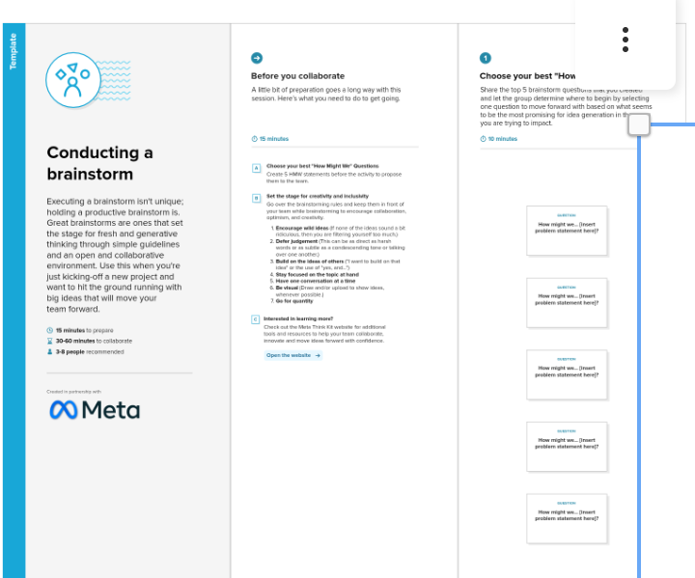

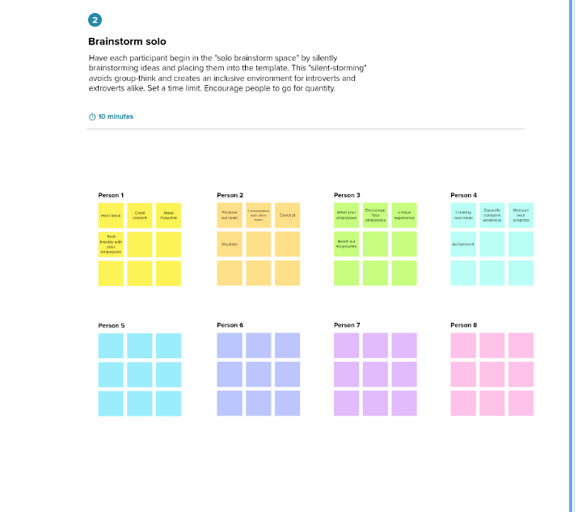

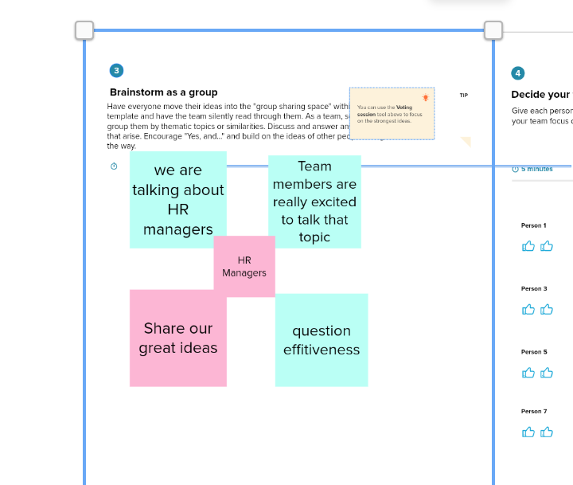**3. Activity**

# Create a user in salesforce;

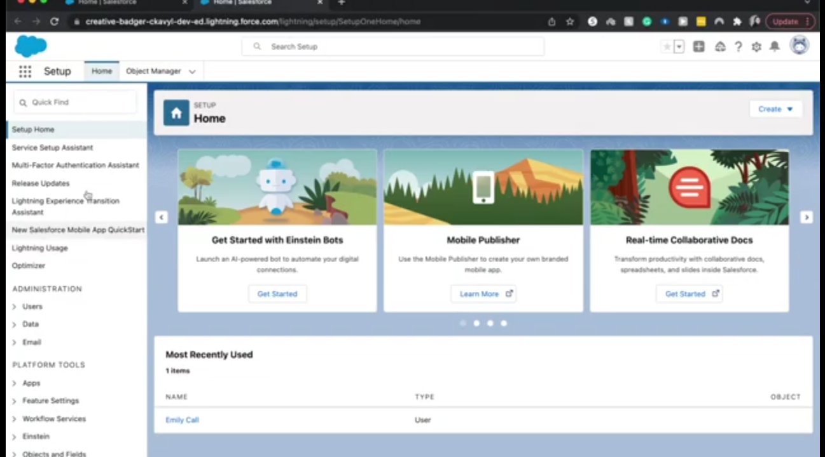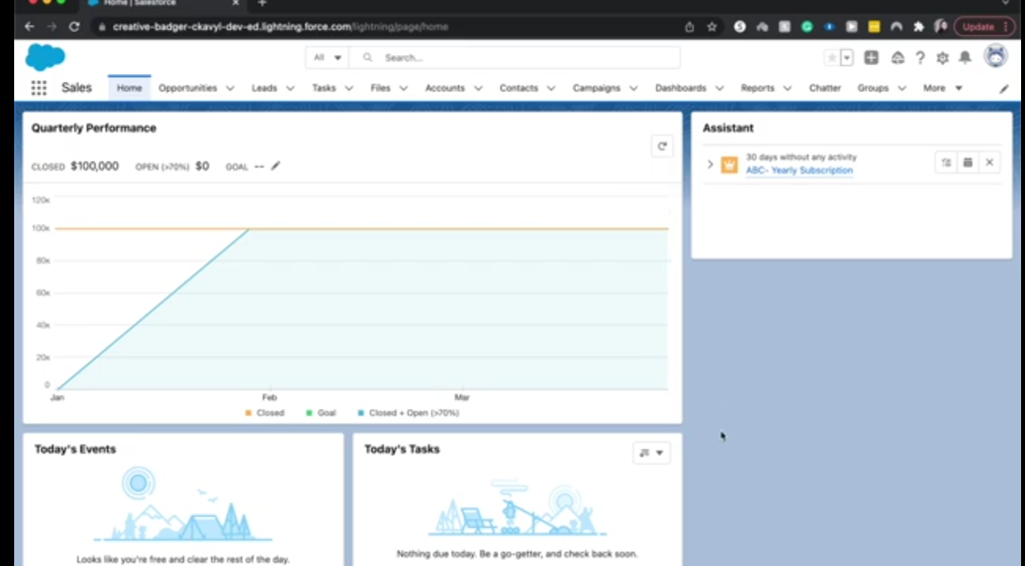

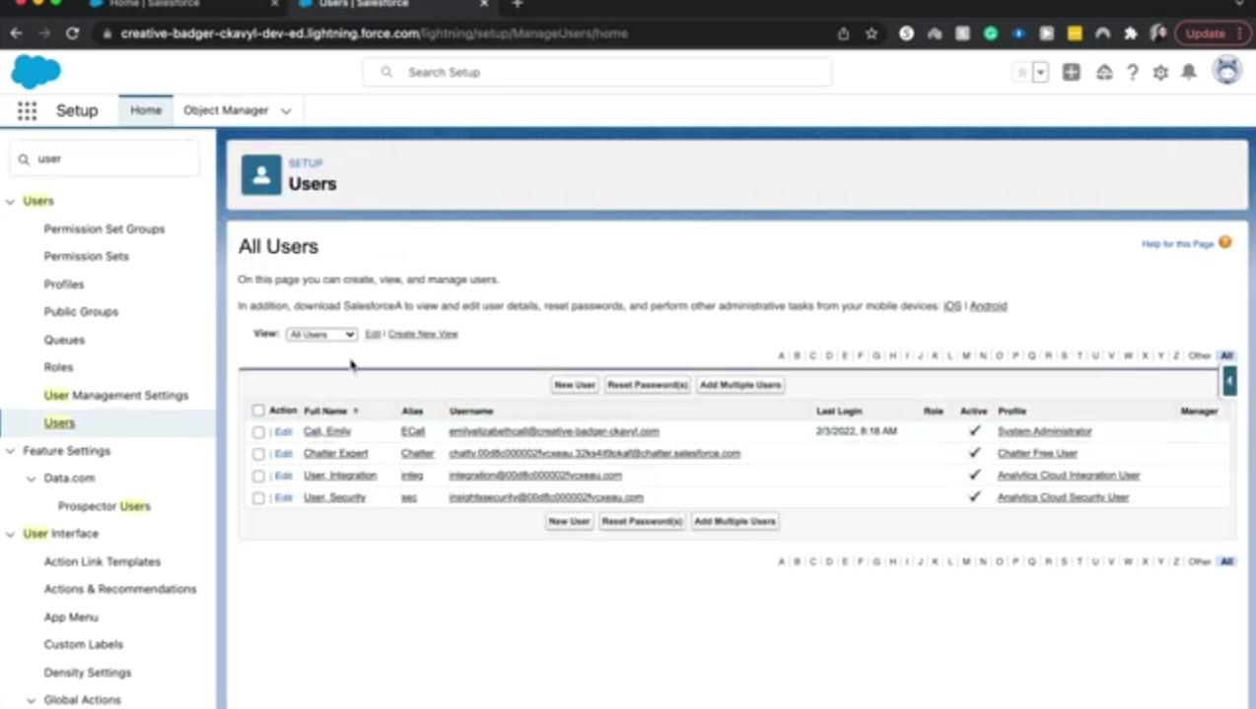

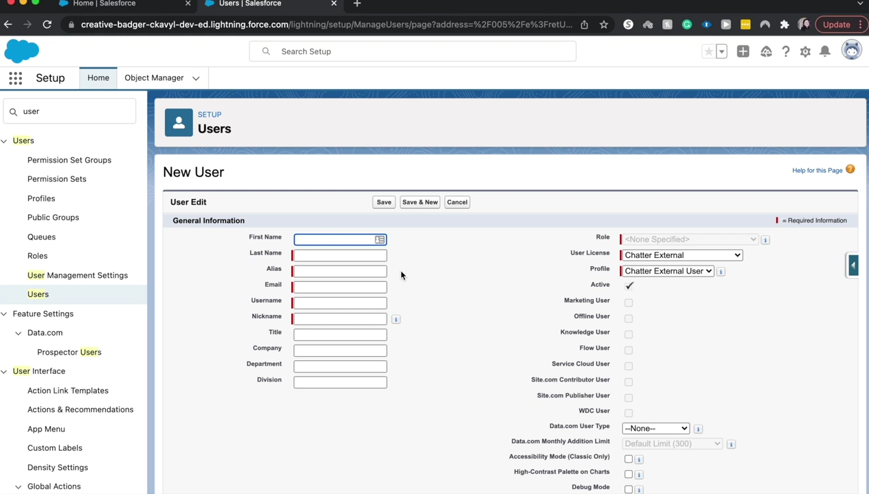

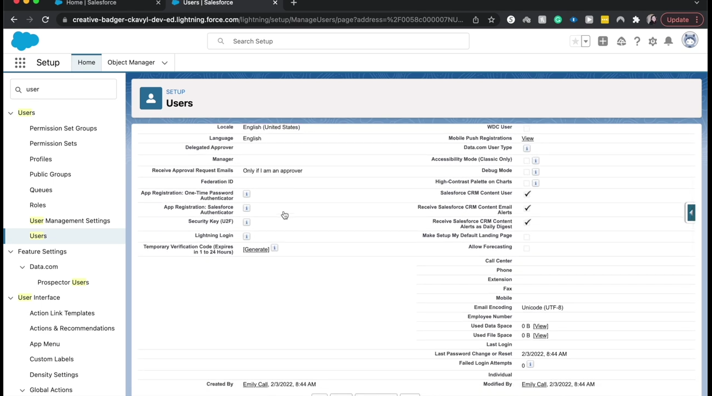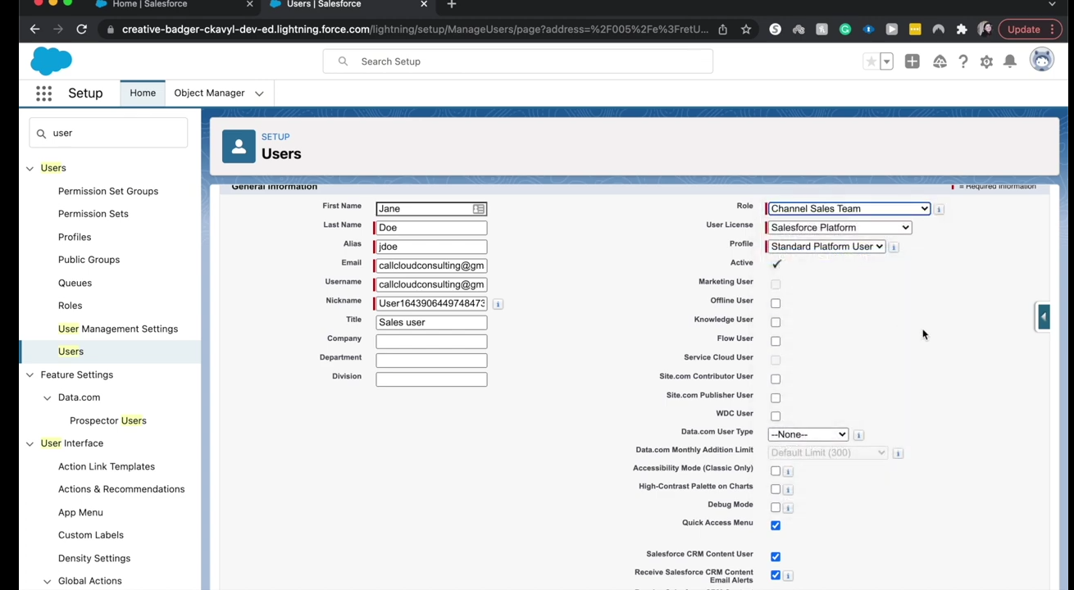

**4. Trailhead profile public** **URL:-**

Team lead- https://trailblazer.me/id/sjayashree1

Team member 1- https://trailblazer.me/id/maha2073

Team member 2- https://trailblazer.me/id/ltmsii

Team member 3- https://trailblazer.me/id/sshift2

5. Applications:-

A human resource information system comes with three major applications – **talent acquisition, talent management, and talent optimization** – all this with the effective backing of data.

6. Advantages of Human Resource Management

**Human Resource Planning**

Human Resource Management (HRM) helps in estimating the right number of people required for carrying out the necessary activities of an organization. It analyses different work positions within a business for identifying the skill sets needed for such positions. Proper information regarding job designations helps in acquiring the right peoples.

**Hiring Workforce**

It enables business in hiring skilled and qualified workforce by creating a large pool of competent peoples. Human Resource Management conducts whole recruitment process of an organization in accordance with the requirements of job positions.

**Retaining Employees**

Human Resource Management plays an efficient role in retaining skilled employees for a longer term within an organization. It monitors working environment provided to workers and ensures that they get hygienic working place, better remuneration, extra benefits and facilities. This leads to long term associations of workers with organization.

**Enhance Organization Effectiveness**

Human Resource Management influences the overall productivity and profitability of a business organization. It is the one which monitors the allocation of all resources and ensures that they are full utilized with minimum wastage. Human Resource Management matches right person with right job which improves the effectiveness of an organization.

**Handles Disputes and Queries**

It handle disputes and resolves all queries of workforce from time to time. Human Resource Management leads to smooth functioning of an organization by redressing all problems of employees in a better manner.

v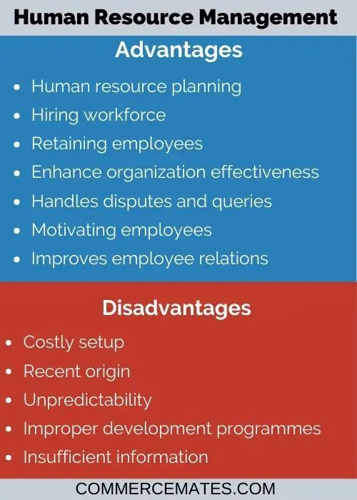

**Disadvantages of Human Resource Management**

**Costly Setup**

Human Resource Management systems require huge costs for installation within the business origination. Owners need to give proper training to its workers for setting up and running these systems. Small business can’t afford to run these systems within their operations.

**Recent Origin**

Human Resource Management lacks universal approval academic base due to its recent origin. There is no uniformity in its terms and different people characterize the term in a distinct way. Organizations are renaming their workforce department as HRM which may not yield real results. It requires changes at a fundamental level in approaches, mentality and philosophy of management.

**Unpredictability**

Another major limitation is inability to predict the external events and behavior of peoples. HRM needs a full support of all working people and top management in an organization for its successful implementation. In absence of proper support from top management, it may not yield expected results.

**Improper Development Programmes**

HRM requires implementation of development programmes such as on job training, career planning, counselling, MBO etc. within the organization. In actual, these development programmes are limited to classroom lectures which undermine this approach in providing the expected outcomes.

**Insufficient Information**

Lack of essential information about workers adversely affects the performance of Human Resource Management systems. These systems require proper database of employees before implementing them. Many organizations do not maintain a proper data of their workforce and therefore need to acquire, retrieve and store the required information.

7. CONCLUSION:-

On the one hand, the Soft and Hard Human Resource Management influence on the business and lets them development rapidly. It can improve employee's motivation in a business and pay attention to company's policy and law respectively, which can increase the efficiency of company and get higher profits.

# FUTURE SCOPE;

The role of HR is continuously evolving, and **HR professionals can aim to learn about the technologies, trends and operational changes shaping the future of business**. HR can be agile in adapting to those changes in order to effectively support employee development, retention and recruitment.

**THANK YOU**